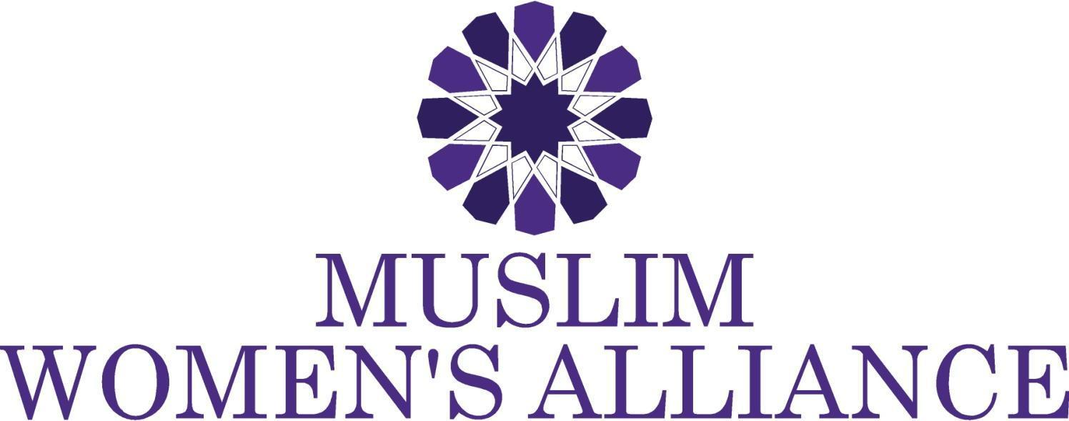

The MWA 2017 Khadija Fund Details
The Muslim Women’s Alliance Khadija Fund is our latest empowerment effort. The purpose of the fund is to remove barriers to entering the workforce. The funds can be used to secure equipment needed to start up a business, certifications, coaching or other items and education that will ensure the recipient's ability to secure employment or launch a business to earn an income and gain financial independence.
MWA will select recipients on an ongoing basis. The amount awarded will differ based on demonstrated need and ability and will range from $250 to $2000

Applicants must fall into one of these categories:
- Female, in possession of skill or talent that has been previously used to earn an income, currently in need of equipment or certification to re-enter workforce.

- Female, currently unemployed and in need of assistance in forms of resume building, technical skill acquisition, computer and technology training with hopes of securing employment.

The MWA 2017 Khadija (RA) Fund Application

Applicants Name: ___________________________________________________________
Address: ___________________________________________________________
City: __________________________________ State:______ Zip:__________
Phone: (H)__________________________ (C) ___________________________
Email: _________________________________________ Age: _____________
How did you hear about this fund?
___________________________________________________________________
Amount requested $

Describe what the funds will be used for (How will the fund remove barriers to earning an income)

What is the estimated monthly income that this fund will enable you to earn?

Submit complete application to fund@mwachicago.org

