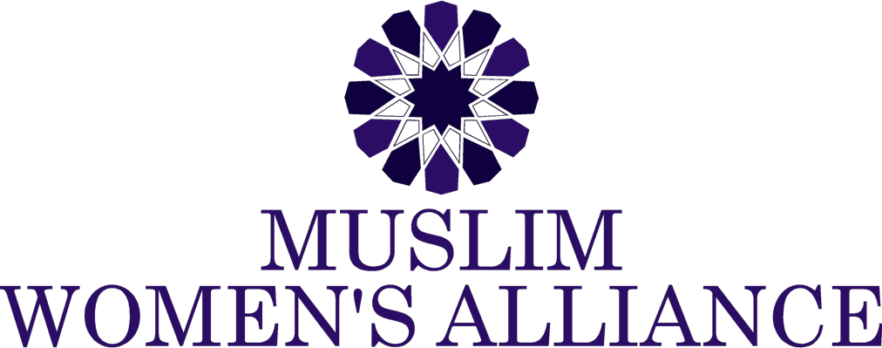

Muslim Women's Alliance 2021 Aisha Scholarship Application
Muslim Women’s Alliance Scholarship program annually empowers female students seeking higher education. Each year as part of our Aisha Scholarship program, MWA grants two Illinois Muslim girls scholarships for higher education. Named after one of the greatest scholars in the history of Islam, the legacy of Aisha (R) will continue to live on today as MWA empowers women who are seeking knowledge.
MWA is offering two separate scholarships, to two separate individuals, in the amount of $2,500.00 each (Two thousand five hundred dollars, only).
Applicants must fall into one of these categories:
- Female, High School graduate, entering into a two-year or four-year college
- Female, currently enrolled in a two-year or four-year undergraduate college program
- Female, entering into, or currently enrolled in a trade school.
Eligible Students:
- Muslim Female; must be at the age of 17 years or older, as of March 1, 2021.
- Must be a U.S. Citizen or a Permanent Resident of the United States, and a resident of Illinois.
- Must be pursuing an Associate’s degree, a first Bachelor’s degree, or pursuing technical or vocational training at an accredited school.
*Students who are graduating with a bachelor’s degree in 2021, and/or those who will be pursuing a graduate degree are ineligible.
To be eligible to apply, the annual household income must not exceed the maximum for the household size as shown in the table below.
Household Size | Maximum Annual Household Income
1 | $25,000
2 | $40,000
3 | $45,000
4 | $52,500
5 | $60,000
6 | $67,500
These guidelines are based and formatted on information from the national average of the U.S. Department of Labor. To adjust for households larger than 6 people, add $7,500 for each additional member.

Requirements to apply: (Please provide proof and documentation for each)
- Accepted to, or currently enrolled in college
- GPA of at least 3.0, or a B average
  - For College: Provide High School or College transcript
  - For Technical/ Vocational Training: Entrance exam results, or letter of reference proving eligibility.
  - Proof of household income
    - For College: FAFSA Application
    - For Technical/ Vocational Training: A copy of the first 2 pages of tax returns; Form 1040 for 2019/2020, together with a copy of the 2020 W-2
    - Demonstrate active participation in community service or philanthropic work (Not necessarily at an Islamic center)
    - 5. Provide two letters of recommendation. The letter can comment on your academic ability, a promise of future success, your extracurricular activities or how your efforts have contributed to the community. Be sure that the letter of recommendation includes contact information for the person writing the letter.
      - One from volunteer/ community service
      - One from school, internship or work
      - Write an essay (Please see below for requirements)
Requirements for the essay:
- Topic: How do you think that the education you will receive empowers you to make an impact in society?
- This impact can be in your home, at school, at work, or in the community.
- Also explain how you would embody the characteristics of a female companion, or one of the wives of our Prophet Mohammed (SAW) to make such an impact.
- Your essay will be judged on creativity, content, style, and grammar.

- Essay must be typed
- Length: 500 - 700 words maximum.
- Font: Times New Roman
- Size of Font: 12
- Line spacing: Double
- Margins: 1 inch all around
- Must have a cover page, with the name of the applicant and the title of the essay
- If any references are being made, the correct citations, in APA or MLA, and reference page.

Application Timeline
- Application deadline: Saturday, March 20, 2021 (Postmarked, or electronic time stamp must be no later than midnight of due date)
- Application selection: March 24, 2021
- Awarded: March 27, 2021
If you have any questions or require assistance with your application, please email: scholarship@mwachicago.org.

